Estimation of Vegetation Condition and changes in Bangalore Urban District through Vegetation Indices

Subrahmanya V Hegde, S. Abdul Rahaman*
Department of Geography, Bangalore University, Bengaluru
‘Subramanyacr7@gmail.com’ abdulatgeo@gmail.com

Abstract

The rapid urbanization and urban sprawling have significant implications for the environment, human well-being, and urban planning in metropolitan cities. Bangalore is the rapidly growing metro city of developing India, hence it is important to study about the vegetation and pressure on vegetation due to urbanization over past few decades is important in order to overcome problems which are caused by the degradation of vegetation cover in Bangalore city. This research paper presents a comprehensive spatiotemporal analysis of Bangalore urban area changes using two key indicators: Normalized Difference Vegetation Index (NDVI) and Enhanced Vegetation Index (EVI). The outcomes of this research provide crucial insights for urban planners, policymakers, and environmentalists striving to create sustainable and resilient cities. The incorporation of EVI, NDVI and their prediction analysis enables a deeper understanding of the ecological consequences of urbanization and aids in the formulation of targeted strategies for urban development and environmental preservation.

Index Terms— Spatiotemporal analysis, NDVI, EVI, urban area changes, green spaces, remote sensing, urbanization, sustainability.

1. Introduction

Understanding the function and dynamics of vegetation in urban environments has grown crucial as the world's population gets more urbanized. There are numerous advantages provided by urban vegetation, such as trees, parks, gardens, and green areas, which support both the sustainability of cities and the general well-being of urban dwellers. Urban vegetation research is important for understanding and to study variety of reasons for green space, urban heat island, varying air quality, biodiversity loss and other urban environmental issues. The study of vegetation is essential to understanding Earth's ecosystems and their dynamics in the fields of remote sensing and environmental monitoring. Measuring changes in land cover, tracking agricultural output, researching the consequences of climate change, and measuring the general health of ecosystems all depend on the study of vegetation.
The idea of vegetation indices is one of the primary methods used to quantify and analyse vegetation features using remote sensing data. Vegetation indices are mathematical formulas that take advantage of the unique ways that vegetation reflects and absorbs light throughout a range of electromagnetic spectrum wavelengths. Such vegetation indices are Normalize difference vegetation index (NDVI), Modified Normalize difference vegetation index (MNDVI), Enhanced vegetation index (EVI), Green NDVI (GNDVI), and Soil adjusted vegetation index (SAVI) etc. These indices are used for various applications such as biomass, crop growth and yield (Huete et al 2002).
Through combinations of various red and near-infrared spectrum reflectance with varying spectral resolutions, vegetation indices precisely assess the crop phenology, classification of vegetation, density of vegetation, seasonal fluctuations, and gross primary productivity (Piao et al. 2020). For tracking changes in vegetation cover, vegetation indices like the normalized difference vegetation index (NDVI) and enhanced vegetation index (EVI) are often employed worldwide (Srivastava et al. 2019). Because of its straightforward estimation, accessibility at various spatial and temporal resolutions, and suppression of noise brought on by solar angle, topographic lighting, clouds, and atmospheric conditions, the NDVI is widely utilized (Matsushita et al. 2007). Due to changes in leaf canopy, NDVI is more saturated at higher biomass levels. We have instead used the EVI to reduce these inaccuracies because it enhances the estimation of biomass level under saturation situations (Huete et al 2002).
The remote sensing dataset like Landsat offers the oldest data record (since 1972) and a spatial resolution that follows the grain of land management, Landsat pictures have historically been the most often used medium-resolution data in studies of above-ground biomass (Cohen and Goward, 2004). Also, Landsat data are typically utilized for classification. The Normalized Difference Vegetation Index (NDVI) and the Enhanced Vegetation Index (EVI) are the two commonly utilized Landsat remote sensing data products for local to world scale vegetation monitoring (Jensen, 2009). For small research sites, the EVI and NDVI algorithm application method may be superior with LANDSAT data than other data’s such as MODIS or VIIRS since it can achieve a better spatial resolution (30 m for TM, ETM+, and OLI), which MODIS and VIIRS cannot (Jarchow et al. 2017). This study focused on NDVI and EVI analysis using LANDSAT data over Bangalore Urban district to achieve these objectives: 1) To understand the vegetation condition of Bangalore Urban District from 1991 to 2021. 2) The relationship between the selected years of NDVI by Pearson correlation, 3) Predicting (2031) NDVI for selected sample sites by regression analysis.

2. Study Area

Bangalore Urban district is one of the 31 districts of Karnataka. It is positioned at 12.97° N 77.56° E and covers an area of 2,190 square kilometres (850 sq mi) and most densely populated district in the Indian state of Karnataka. It is a part of Bangalore Metro Politian Region (BMR). It is surrounded by the Bangalore Rural district on the east and north, the Ramanagara district on the west and the Krishnagiri district of Tamil Nadu on the south. Bangalore Urban has three Taluks: Bangalore City, Yelahanka and Anekal. According to 1991 census Bangalore Urban had population of 4,839,162, As of Census 2011, its population has increased to 9,621,551 at present it may have increased by 12,765,000 as per Macrotrends survey.
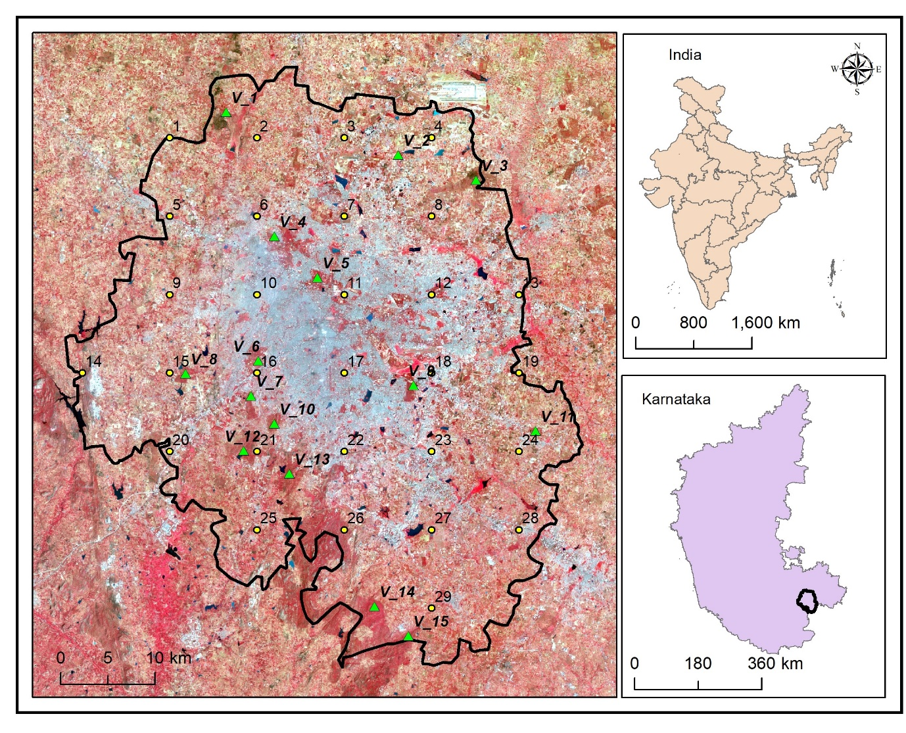
Figure.1. Study area

3. Dataset Requirements and Methods

Landsat data comes in a variety of wavelength-based bands (blue, green, red, infrared, thermal, and panchromatic). Data resolution is increased by using a panchromatic band. Data from Landsat 7 has a total of 8 bands, whereas data from Landsat 8 has 11 bands. Only three bands (Blue, Red, and NIR) are employed for the analysis of the Normal Difference Vegetation Index (NDVI) and the Enhanced Vegetation Index (EVI) (Kshetri. 2018). The LANDSAT 5 and 7 satellites' Thematic Mapper (TM) and Enhanced Thematic Mapper Plus (ETM+) sensors constantly capture images of the Earth with a 16-day repeat cycle. Images captured by LANDSAT TM and ETM+ have spectral bands with a spatial resolution of 30 m (Maseket al., 2006). In the present study following datasets were used (Tale1).
Table .1 Data set description
Sensor | Month / year | Resolution | Selected bands
Landsat 5 | February / 1991 | 30 m | Band 3 & 4
Landsat 7 | February / 2001 | 30 m | Band 3 & 4
Landsat 7 | February / 2011 | 30 m | Band 3 & 4
Landsat 8 | February / 2021 | 30 m | Band 4 & 5

3.1. NDVI Calculation

The "greenness" of the vegetation canopy is a characteristic of photosynthetic activity, leaf area, and vegetation structure. NDVI and EVI are ratios that include red and near infrared (NIR) reflectance bands (Huete et al 2002). The amount of photosynthetically active vegetation on terrestrial surfaces is thought to be directly and causally related to the ratio of reflectance from red wavelengths absorbed by photosynthetic pigments (e.g., chlorophyll) and NIR wavelengths scattered by leaf mesophyll cells (Mynen et al. 1995). Mathematically NDVI is calculated by following formula
NDVI= (NIR – R) / (NIR + R)

Where NDVI is normalized difference vegetation index. R and NIR are spectral radiance (or reflectance) measurements recorded with sensors in red (visible) and NIR regions, respectively. NDVI values range from -1 to 1. Its values are positive for vegetation, such as crops, bushes, grasses, and forests, and close to zero for surfaces made of rocks, sand, or concrete. Usually negative for waterbody. To put it another way, higher NDVI levels have larger consequences for lush vegetation (Jones and Vaughan. 2010).

3.2. EVI Calculation

The enhanced vegetation index (EVI) is to improve vegetation monitoring, improve sensitivity of the vegetation signal in high biomass locations, and decouple the background signal from the canopy (Huete, Justice, & Liu, 1994). Because of its enhanced saturation resilience and resistance to soil and atmospheric contamination, EVI has been suggested as a more reliable proxy for forage biomass and quality than NDVI. Similar to NDVI, EVI is a ratio of red and NIR reflectance, but it also has additional components, such as a blue band to lessen atmospheric contamination of the red band, an adjustment factor to account for soil non-linear distortion (L=1), and aerosol resistance coefficients, C1 = 6, C2 = 7.5 (Huete et al 2002). Mathematically EVI is calculated by following formula

EVI = [G (NIR-R) / (NIR + C1 R-C2 * B + L)]

Where EVI is Enhanced Vegetation Index. R, B and NIR are spectral radiance (or reflectance) measurements recorded with sensors in red, blue (visible) and NIR regions, respectively. C1, C2 are the coefficients of the aerosol resistance term, which uses the blue band to correct for aerosol influences in the red band. The coefficients adopted in the EVI algorithm are, L = 1, C1 = 6, C2 = 7.5, and G (gain factor) = 2.5.

4. Result

The study revealed that vegetation of study area is keeps on changing from past four decades. NDVI of 1991 has range of 0 - 0.2 as maximum up to nearly 90%, and highly vegetated regions with range of >6 is very minimum with nearly 1%, we can see that vegetation less areas around 2 – 3% with range of 0, finally nearly 5% area is covered by light vegetation with the range of 0.4-0.6 (Fig.2.a). NDVI of 2001 shows (Fig.2.b) the rapid urbanization in the central region of Bangalore ranging 0 about 30% without any vegetation. Vegetation of urban region has improved from with respect to previous year because range of 0.4-0.6 has increased to about 50%. Highly vegetated area with range of >0.4 is about 5%.

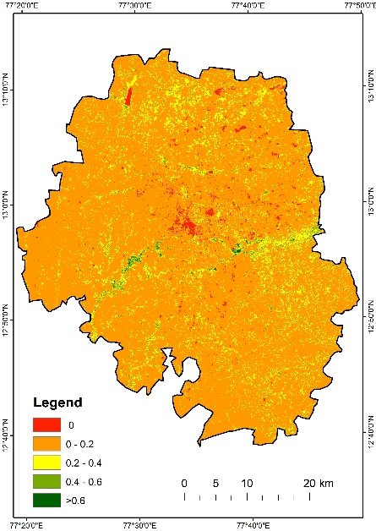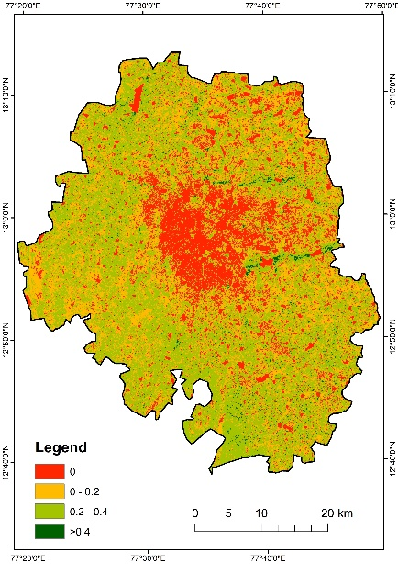
a)
b))

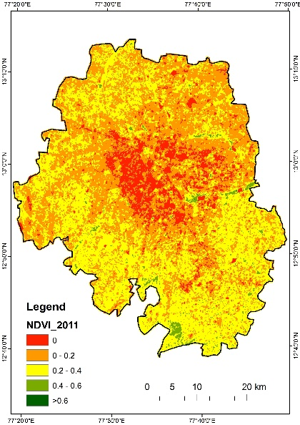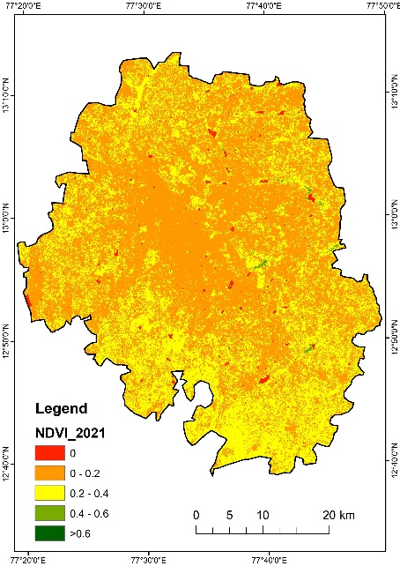
c
d
Figure.2 a) NDVI 1991; b)2001; c)2011; d)2021

In the next decade urban sprawling can be detected, in 2011 we can see that reduction of vegetation range from 0.4-0.6 to 0.2-0.4 (Fig.2.c). Central region of study area has no vegetation with range of 0 about 40%, maximum range in 2011 is 0.2-0.4 and minimal range is >0.6 containing dense vegetation. In 2021 (Fig.2.d) shows the positive changes in the central region of study area by reduction of range 0 and increase in range of 0-0.2 by 60%.

4.1. Correlation

Correlation coefficients measure how strong and in which direction two variables are linked in a straight line. Correlation matrix of 1991, 2001, 2011 and 2021 shows that there is a more similarities between 2021 and 2011 which states the positive changes. Same matrix shows that between 2021 and 1991 there is least similarities which states that there is a negative change between the years (Table 2).

Table .2 Data set description
 | 1991 | 2001 | 2011 | 2021
NDVI1991 | 1 | 0.229 | 0.261 | 0.187
2001 | 0.229 | 1 | 0.52 | 0.417
2011 | 0.261 | 0.52 | 1 | 0.603
2021 | 0.187 | 0.417 | 0.603 | 1

4.2. NDVI Prediction Based on Regression Analysis

Here 15 Vegetation sites are selected as sample points all around the study area, to predict vegetation condition of those location in the year 2031 using Regression analysis. According to the study only one of Vegetation site among 15 is showing negative change, that is NDVI value in 2021 is 0.241 and it has reduced to 0.192 (Table 3). Except this point all other location shows positive changes with increase in NDVI values. Here maximum R² value indicates positive changes, whereas minimum R² value indicates negative changes.

Table .3 Predicted NDVI vales of selected vegetation sites
ID | 1991 | 2001 | 2011 | 2021 | 2031 | R²
1 | 0.282 | 0.236 | 0.183 | 0.241 | 0.192 | 0.309
2 | 0.110 | 0.348 | 0.476 | 0.347 | 0.531 | 0.504
3 | 0.113 | 0.208 | 0.157 | 0.222 | 0.244 | 0.507
4 | 0.288 | 0.333 | 0.365 | 0.221 | 0.249 | 0.126
5 | 0.263 | 0.231 | 0.356 | 0.266 | 0.312 | 0.101
6 | 0.048 | 0.125 | 0.263 | 0.170 | 0.278 | 0.526
7 | 0.130 | 0.223 | 0.250 | 0.214 | 0.275 | 0.485
8 | 0.133 | 0.200 | 0.318 | 0.249 | 0.342 | 0.593
9 | 0.101 | 0.206 | 0.224 | 0.204 | 0.266 | 0.573
10 | 0.231 | 0.220 | 0.262 | 0.240 | 0.256 | 0.254
11 | 0.111 | 0.268 | 0.451 | 0.277 | 0.446 | 0.399
12 | 0.140 | 0.172 | 0.310 | 0.220 | 0.305 | 0.432
13 | 0.083 | 0.270 | 0.333 | 0.261 | 0.386 | 0.513
14 | 0.118 | 0.333 | 0.435 | 0.306 | 0.465 | 0.423
15 | 0.114 | 0.328 | 0.429 | 0.290 | 0.427 | 0.382
Also, another 28 random sample sites were selected based on grid method for Regression analysis to predict vegetation condition in the year 2031. After the assessment there are total 6 sites are showing negative changes with decrease in NDVI values (Table 4). Some of them might be the non-vegetation site as they are selected by grid method. R² values indicates positive or negative changes in the NDVI. Therefore, we need to focus more on this location in order to maintain its greenness in and around areas.

Table .4 Predicted NDVI vales of selected random sites
ID | 1991 | 2001 | 2011 | 2021 | 2031 | R²
1 | 0.09 | -0.02 | 0.21 | 0.24 | 0.30 | 0.54
2 | 0.03 | 0.14 | 0.16 | 0.16 | 0.23 | 0.77
3 | 0.16 | 0.09 | 0.14 | 0.20 | 0.19 | 0.22
4 | 0.06 | 0.26 | 0.28 | 0.23 | 0.34 | 0.46
5 | 0.02 | -0.04 | 0.05 | 0.11 | 0.12 | 0.57
6 | 0.06 | 0.08 | 0.06 | 0.20 | 0.20 | 0.61
7 | 0.09 | -0.05 | 0.16 | 0.16 | 0.20 | 0.31
8 | 0.07 | 0.28 | 0.19 | 0.21 | 0.26 | 0.21
9 | 0.01 | -0.12 | 0.00 | 0.11 | 0.10 | 0.29
10 | 0.21 | 0.10 | 0.16 | 0.25 | 0.23 | 0.11
11 | 0.06 | -0.19 | 0.00 | 0.13 | 0.11 | 0.16
12 | 0.07 | 0.31 | 0.27 | 0.23 | 0.33 | 0.3
13 | 0.09 | 0.20 | 0.22 | 0.15 | 0.21 | 0.18
14 | 0.10 | 0.26 | 0.17 | 0.13 | 0.16 | 0
15 | 0.49 | 0.24 | 0.05 | 0.07 | -0.15 | 0.84
16 | 0.00 | -0.22 | -0.05 | 0.06 | 0.03 | 0.13
17 | 0.42 | 0.13 | 0.04 | 0.08 | -0.11 | 0.7
18 | 0.16 | 0.22 | 0.27 | 0.11 | 0.16 | 0.05
19 | 0.05 | 0.26 | 0.22 | 0.16 | 0.25 | 0.17
20 | 0.07 | 0.29 | 0.21 | 0.21 | 0.29 | 0.23

4.3. Vegetation Change Detection

Image difference analysis is per pixel image difference detection between two images. By this study we can clearly get to know about the changes that can be detected from 1991 to 2021. Figure 3a represents highlights changed from the year 1991 to 2021; the red color denotes the vegetated area in 1991 has reduced or decreased by 2021 representing negative impacts of urbanization on vegetation. Whereas the green color represents increase in the vegetation by 10% from 1991 to 2021 which represents positive developments in outskirts of city.
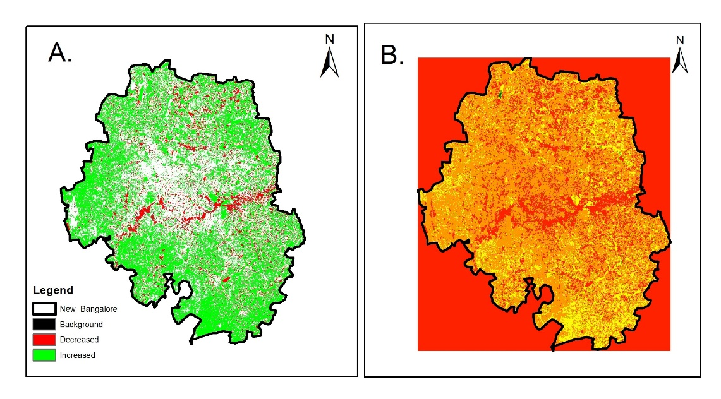
Figure.3 a) vegetation increases and decrees; b) overall difference

4.4. Enhance Vegetation Index
EVI analysis is used to quantify the vegetation greenness in the Bangalore urban district. According to the results in the year 1991 there is a moderate vegetation in our study area, when compared with 2001 we can see the urbanization processes which are started and slight reduction in the vegetation. In the year 2011 there is a drastic reduction in the vegetation greenness and rapid urbanization can be observed. In the year 2021 we can see a lot of positive changes and developments as there is lot of vegetation greenness can be observed. More greenness in outskirts of the city centre can be observed in 2021 (Fig.4).

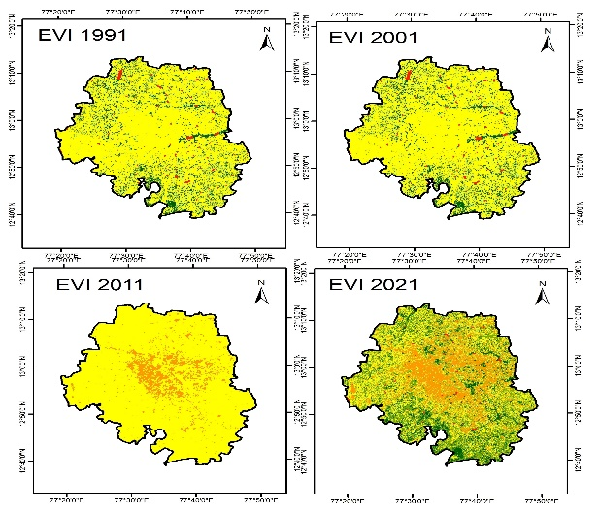
Figure.4. EVI of 1991, 2001, 2011, 2022

5. Conclusion

In this study Landsat 5 TM, Landsat 7 ETM+ and Landsat 8 OLI data sets are used for the Study of vegetation condition in the Bangalore Urban district of Karnataka state of India. Vegetation indices such as Normalized differential Vegetation Index and Enhanced Vegetation Index was calculated for the years 1991, 2001, 2011, and 2021. Both the study showed that there is a reduction in the vegetation till the year 2011, but from 2011 to 2021 there is a positive change in the Vegetation condition. By this study we can focus on the sustainable urbanization concept, so that human activities that alters the natural vegetation can be reduced and also to increase this trend of positive changes

6. Acknowledgement

The authors are thankful to Department of Geography and Geoinformatics for providing lab facility to carryout the analysis. Also, thank the USGS for the Landsat data products.

7. References

[1] Huete, A., Didan, K., Miura, T., Rodriguez, E., Gao, X., & Ferreira, L. (2002). Overview of the radiometric and biophysical performance of the MODIS vegetation indices. Remote Sensing of Environment, 83(1-2), 195-213. https://doi.org/10.1016/S0034-4257(02)00096-2

[2] Piao, S., Wang, X., Park, T. et al. Characteristics, drivers and feedbacks of global greening. Nat Rev Earth Environ 1, 14–27 (2020). https://doi.org/10.1038/s43017-019-0001-x

